[E121] Fuse

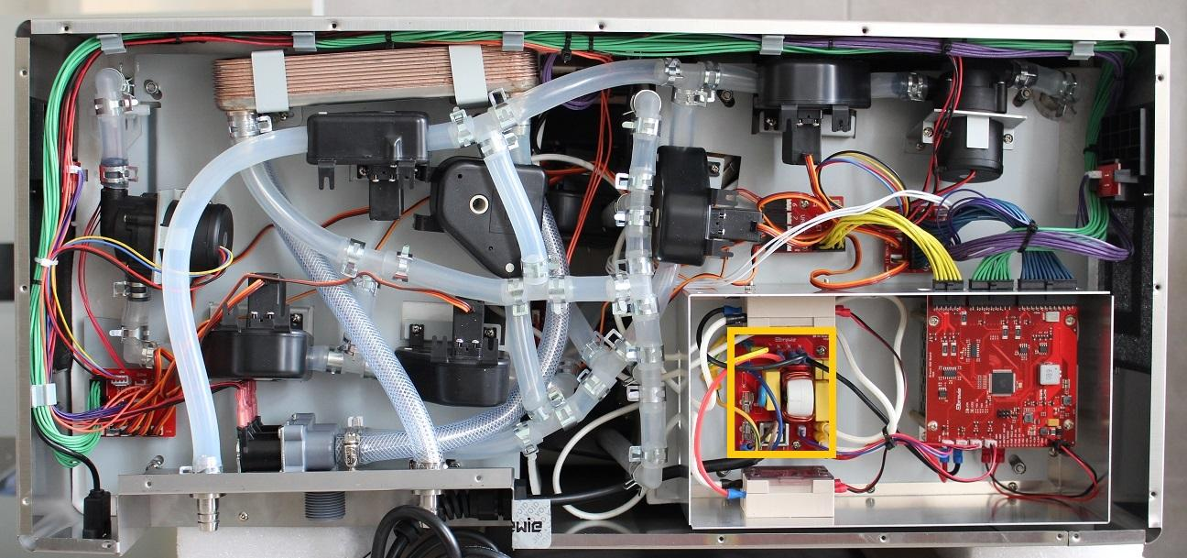

The fuse is located on the high voltage PCB.

Replace the indicated fuse. The new fuse must have the same properties as that we removed one.

